On Launching URL: <https://www.sportskeeda.com>

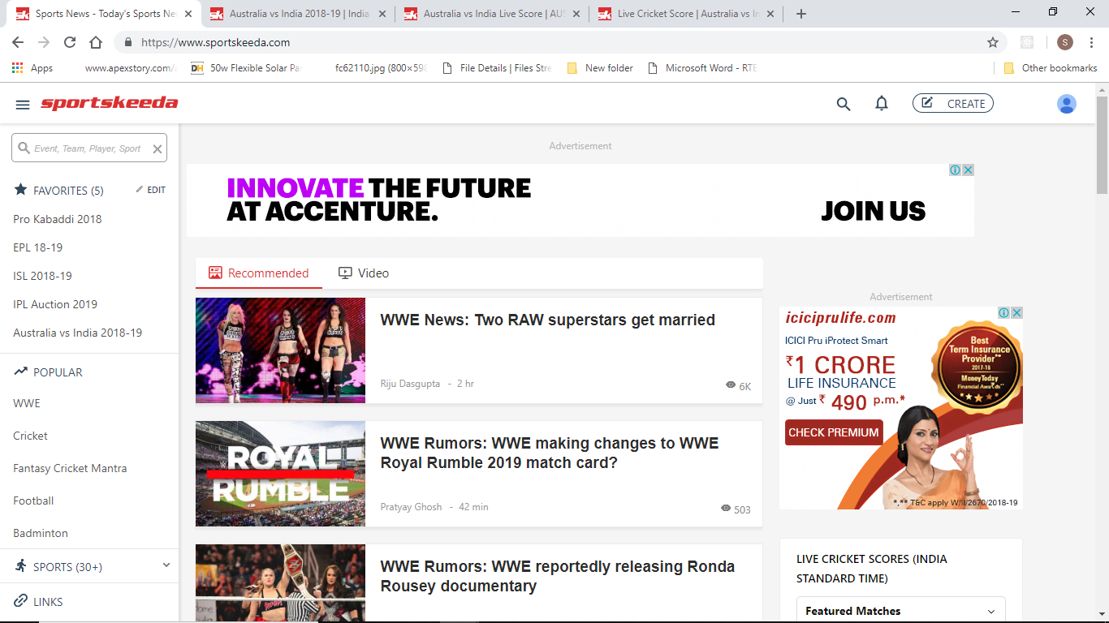

User is able to select Australia vs India:

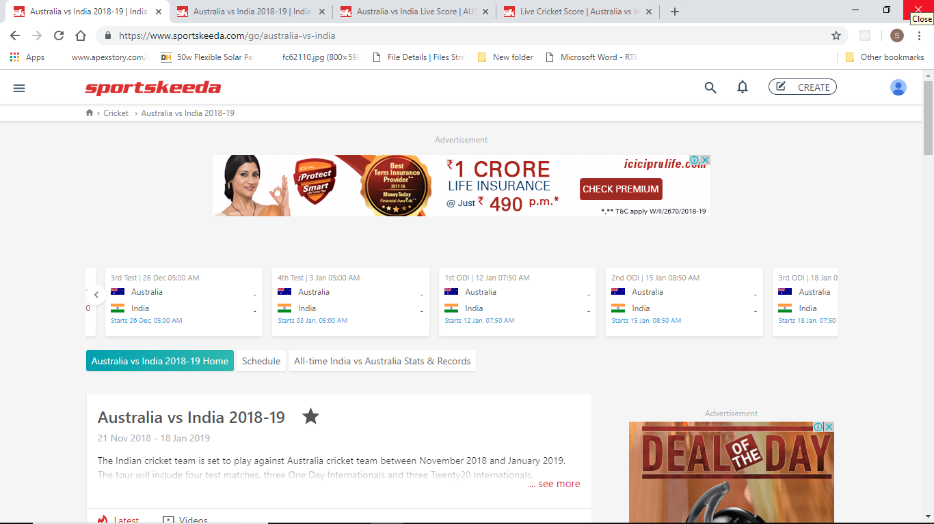

User is able to see the match Schedule for respective tournament:

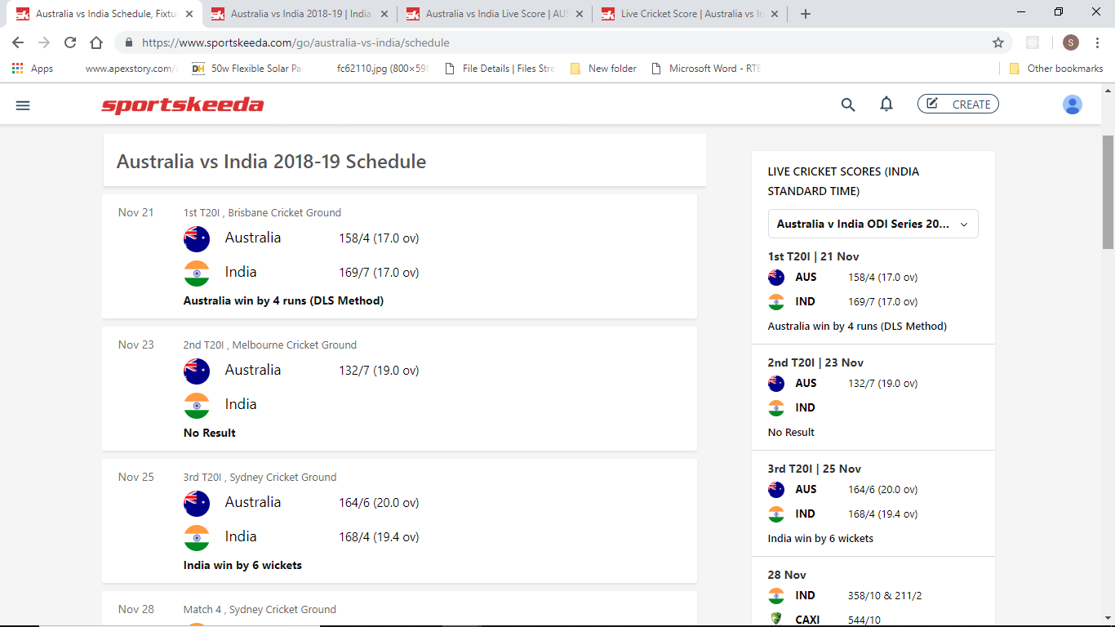

For match in Progress or Completed Commentary and Scorecard Tab is visible:

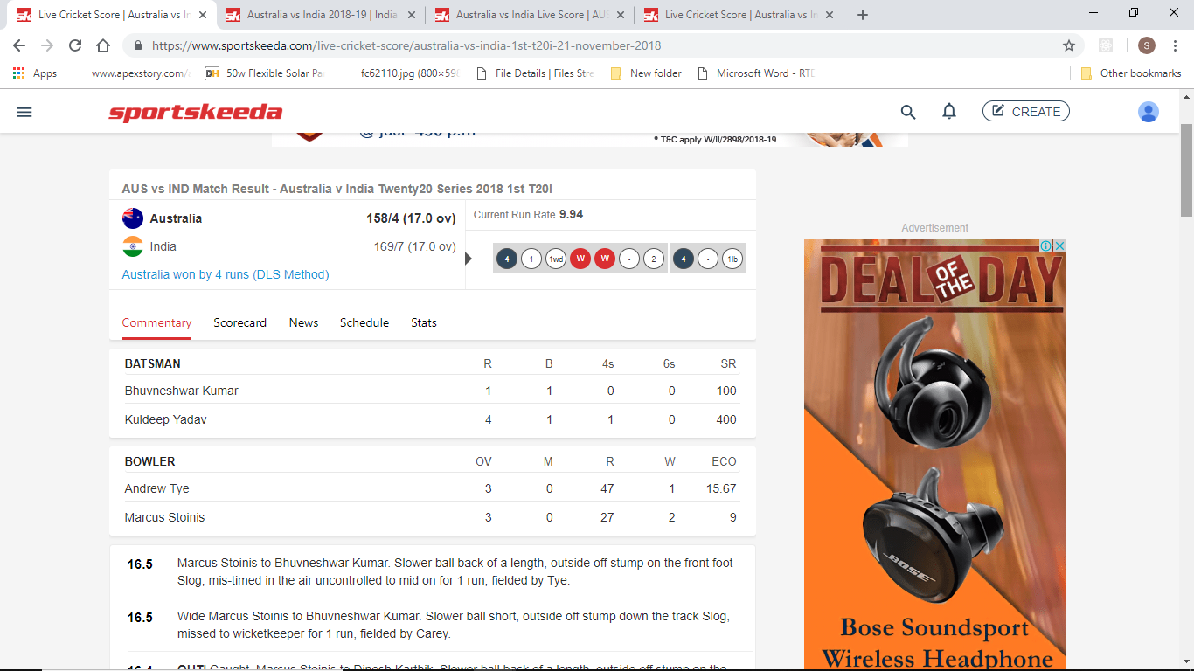

For matches yet to start Preview Tab is present instead of Commentary or ScoreCard:

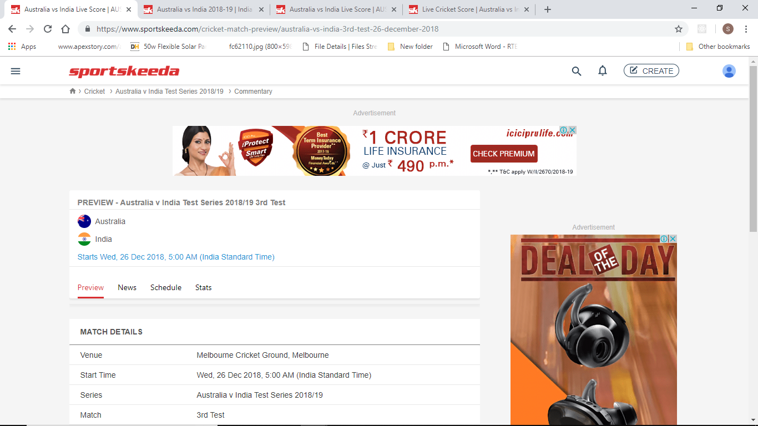

If Stats is present for the particular tournament/series user is able to see the Bowling and Batting Stats:

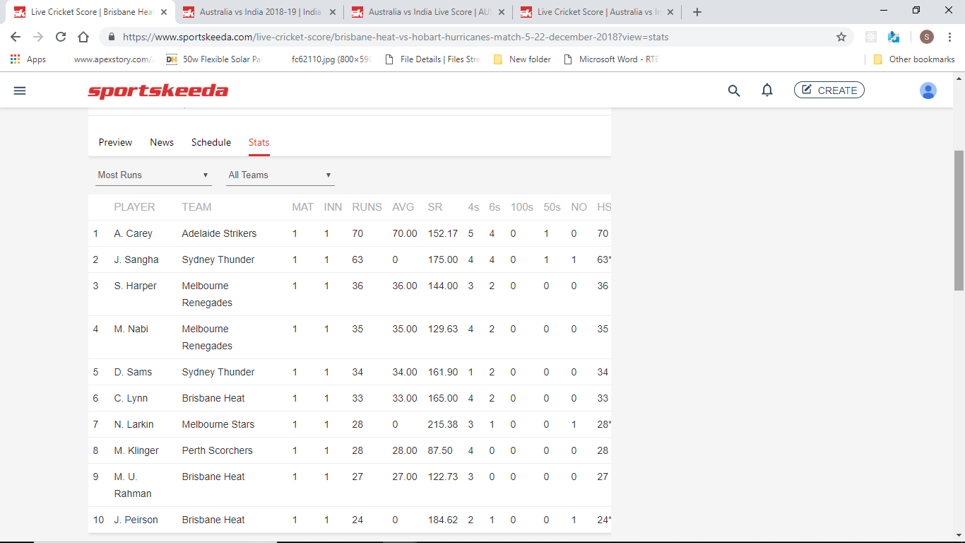

For Australia vs India

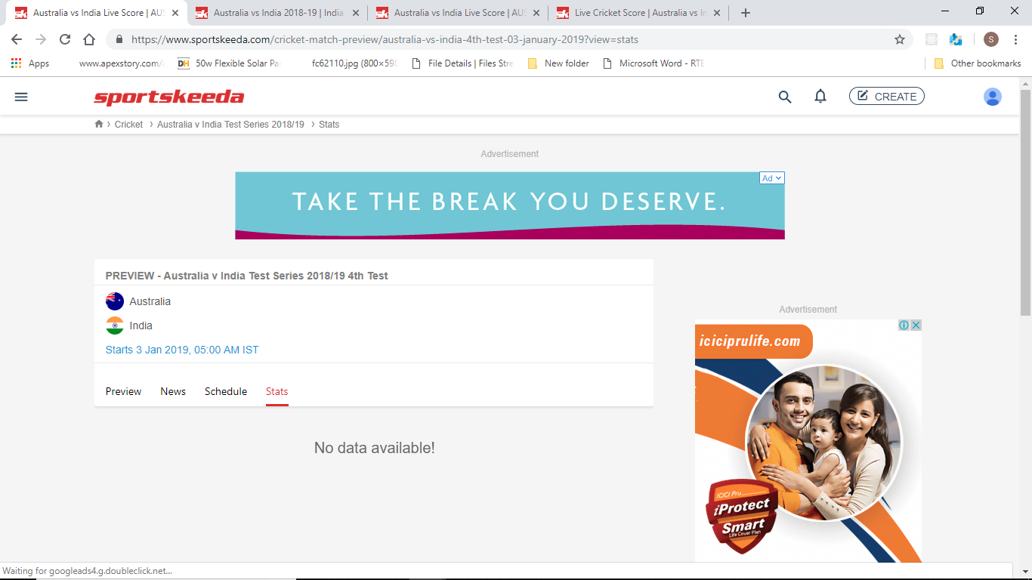

Mobile View:

On launching the URL: <https://m.sportskeeda.com>

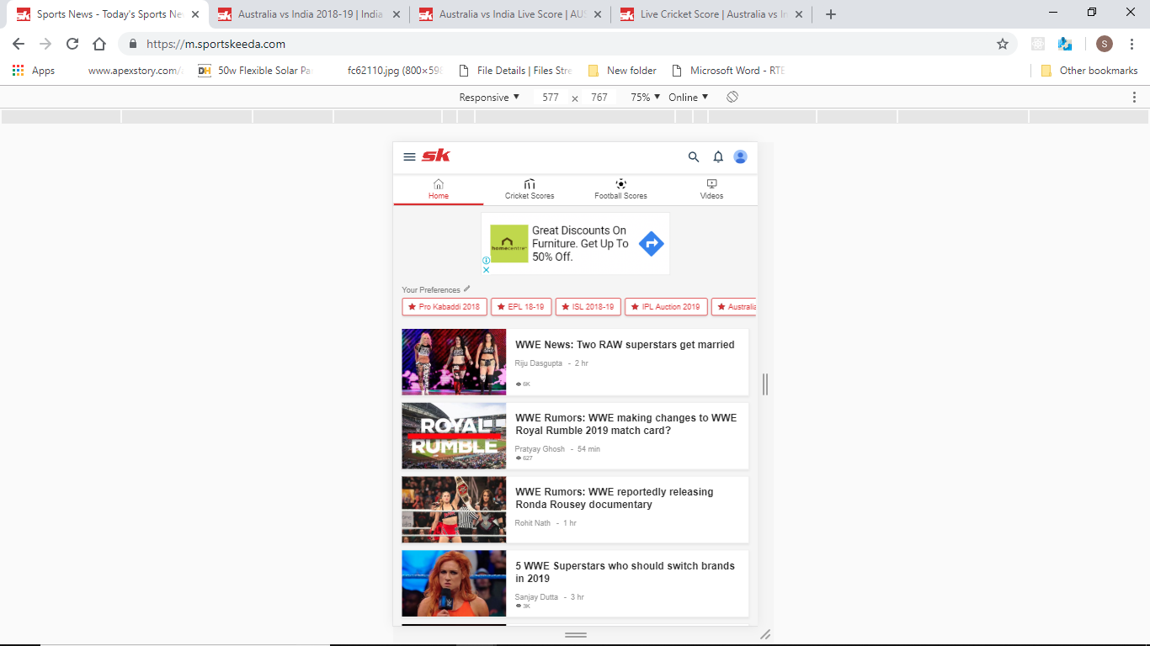

On clicking the Hamburger Icon and selecting Australia vs India:

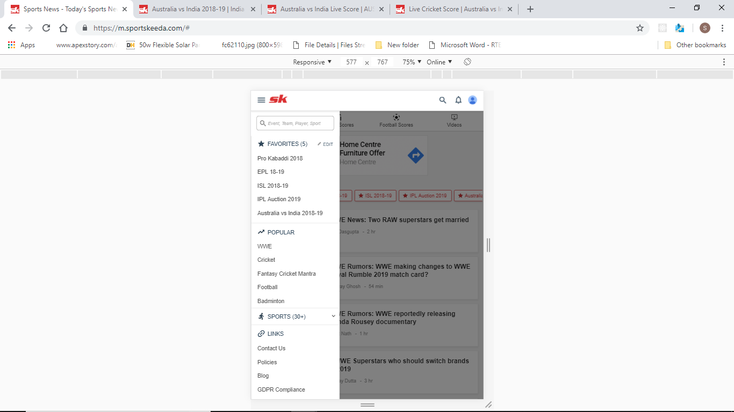

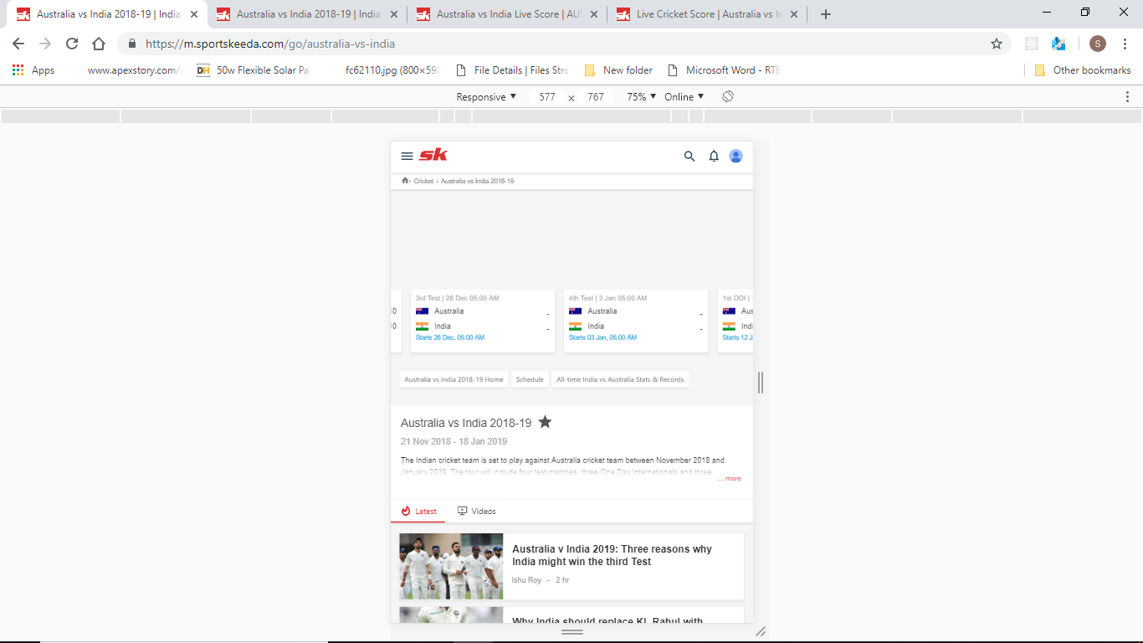

User is able to see the schedule in the tournament, and details regarding the status of the match:

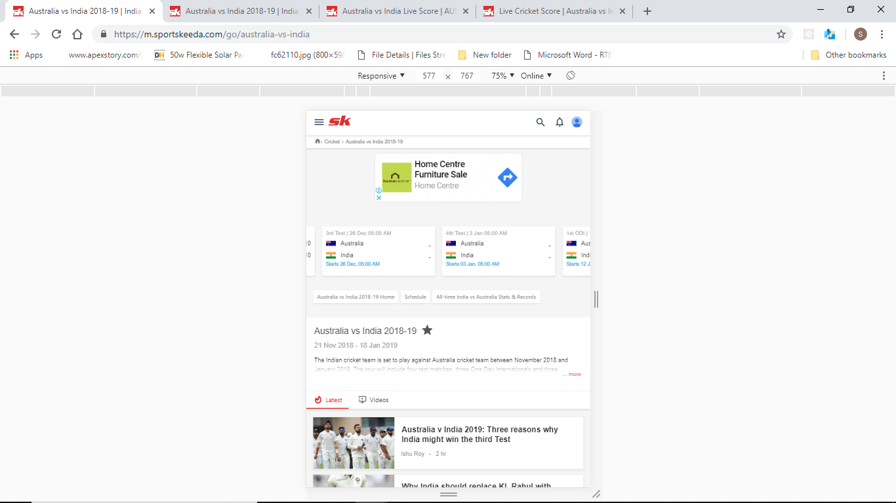

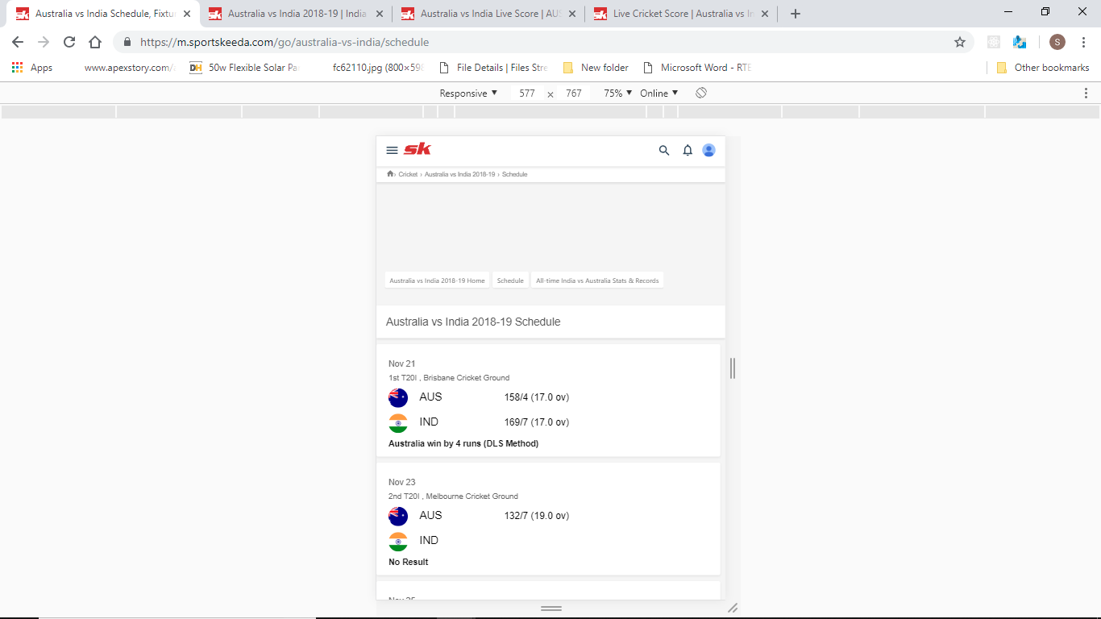

For matches completed Commentary and Scorecard tabs are present:

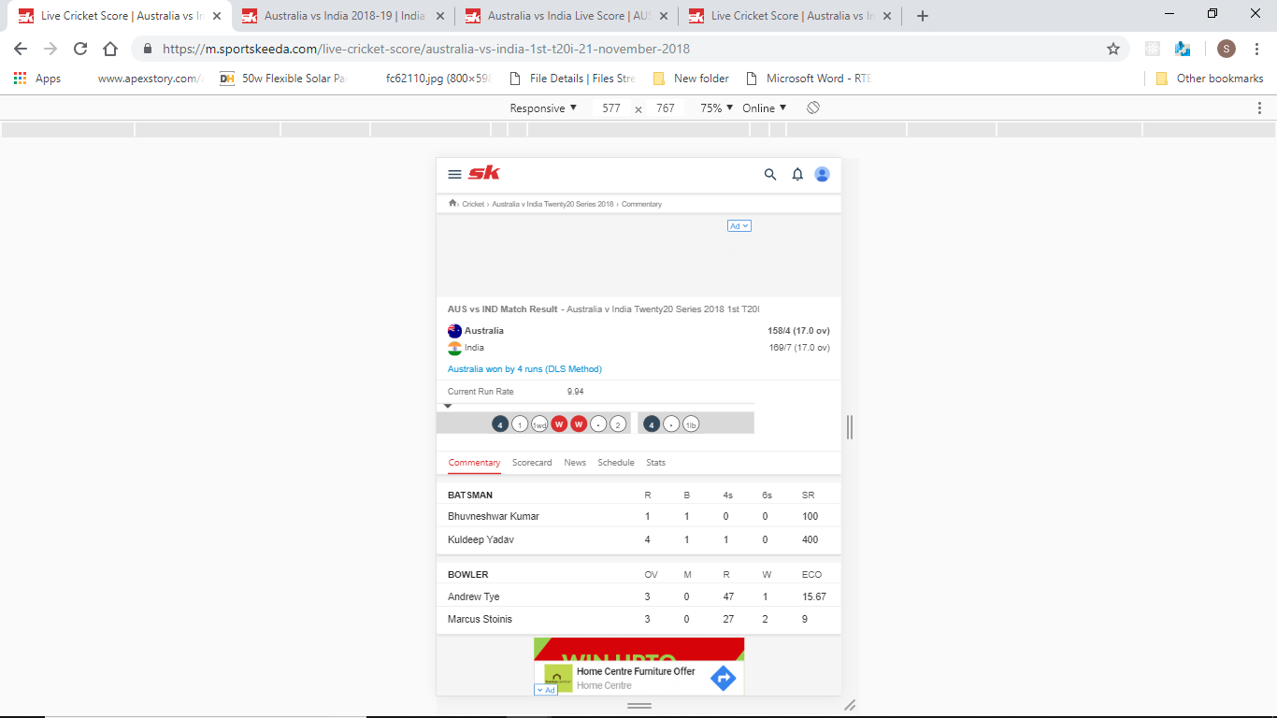

For matches yet to start Preview tab is present instaed of Commentary and Scorecard:

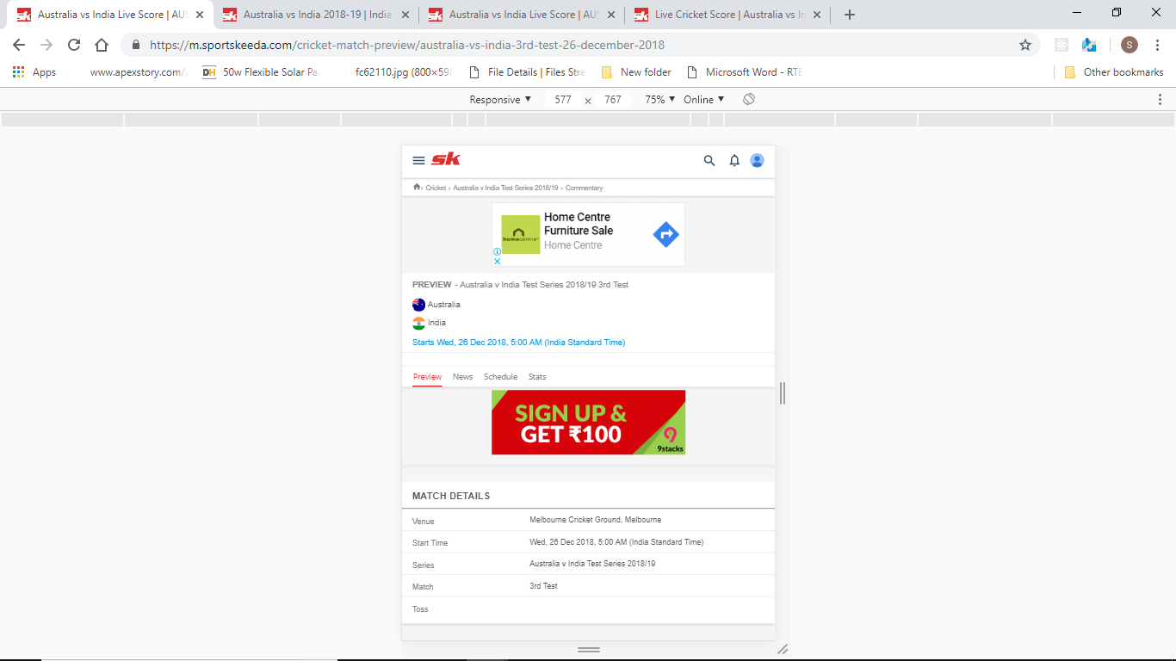

Under Alltime Records for Australia Vs India No data is present for Batting Stats so the second column collapses and causes discrepancy in the UI of mobile devices:

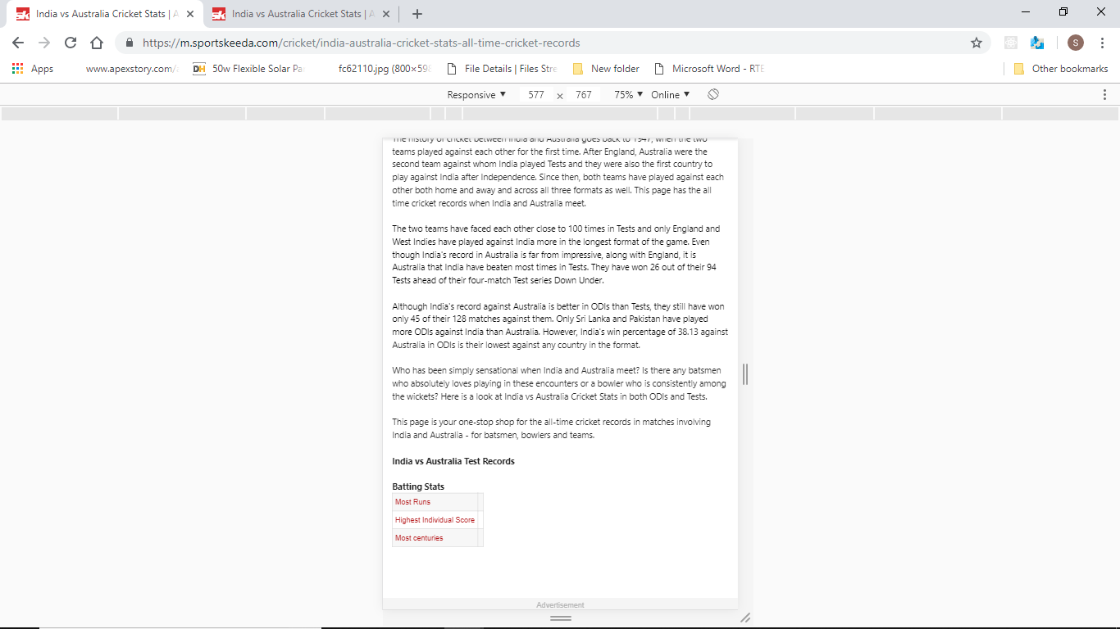

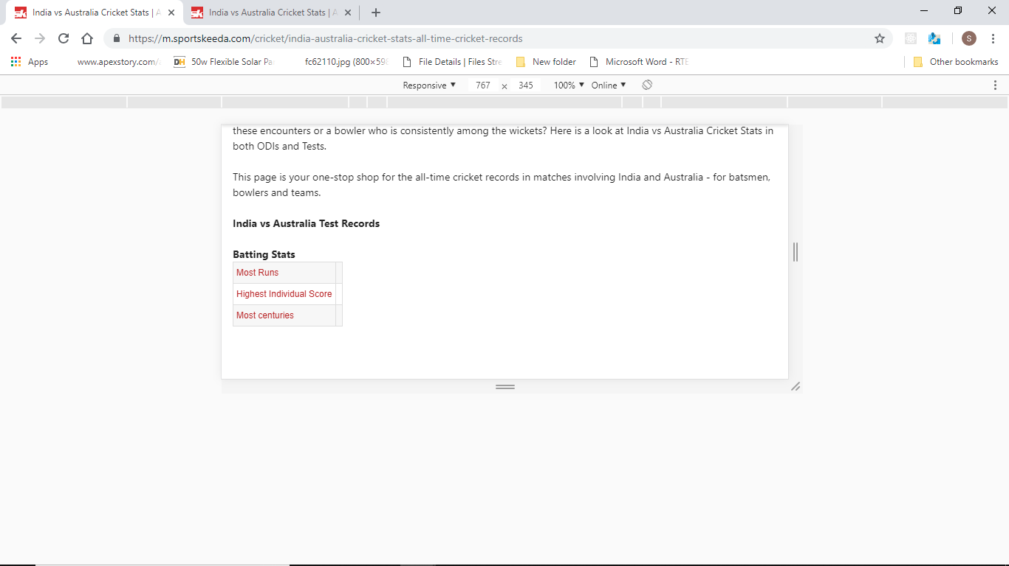

Desktop:

